# Community Financial Management

### Accounts, Invoicing & Online payments

* + Raise invoices for various society charges.
  + Set rules based on size of flat or usage.
  + Invoicing for groups or individuals.
  + **Option to configure any kind of penalty.**
  + Bulk charge items for invoicing.
  + Ability to collect payment online
  + Ability to accept payment by EMI
  + **Collect partial payments**
  + Mobile dashboard for residents
  + **View dues based on selected date**

### Payment collection

* + **Capture all payment collection modes.**
  + Accept partial payment of charges.
  + Acknowledge payment via email/SMS/Whatsapp.
  + Bulk downloads of receipts.
  + Link/Configure bank account for selected bills.x

### Reports and reconciliation

* + View date-wise dues for an account or bill.
  + View payment collection by account.
  + View collections based on payment mode.
  + Auto-reconciliation.
  + Download reports to your device.

**Module: Community Financial Management**

**Version: Web and Mobile**

Description: This module will help the community management to collect the fixed monthly payments and generate invoices against them. This module will cover following activities:

***Accounts, Invoicing & Online payments***

1. Raise invoices for various society charges.
2. Set rules based on size of flat or usage.
3. Invoicing for groups or individuals.
4. Option to configure any kind of penalty.
5. Bulk charge items for invoicing.
6. Ability to collect payment online.
7. Ability to accept payment by EMI
8. Collect partial payments
9. Mobile dashboard for residents
10. View dues based on selected date

***Payment collection***

1. Capture all payment collection modes.
2. Accept partial payment of charges.
3. Acknowledge payment via email/SMS / WhatsApp.
4. Bulk downloads of receipts.
5. Link/Configure bank account for selected bills.

***Reports and reconciliation***

1. View date-wise dues for an account or bill.
2. View payment collection by account.
3. View collections based on payment mode.
4. Auto-reconciliation.
5. Download reports to your device.

This module will be implemented on both Web and Mobile version. The feature of the modules will be divided as follows:

**Web Version:**

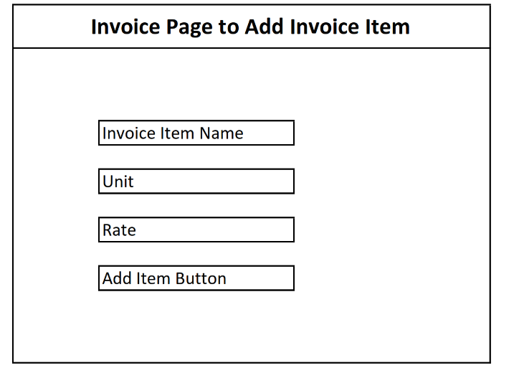Web version of the module will be used by the admin accounts to generate invoice of the communities. This module will include following screens to implement its features.

**Page: 1** In this page Admin accounts will add the heads of invoices, these heads will be used to populate the invoice items by multiplying the unit rate and quantity.

**Page 2:** In this page All the resident records will be visible with their flat number. To generate the invoice admin accounts will select the financial year, then select the month of that financial year. On pressing Generate invoice button following operations will be performed.

1. Common Area Maintenance charges will be calculated by multiplying the Flat area to Rs. 2.50.
2. Energy Charges (DG) will be calculated by number of units multiplied to Rs. 30. The Units will be entered by the admin accounts by using view option later into the list. Later it will be fetched by the API if available.
3. After that by adding all items amount, Gross Amount before taxes will be calculated.
4. CGST 9% and SGST 9% will be added on total amount.
5. By adding Gross Amount + CGST 9% + SGST 9% = Total Amount After Taxes will be calculated.
6. The amount in case of advance payment will be deducted from Total Amount After Taxes
7. Total Amount After Taxes – Less: Advance Adjusted = Net Payable Amount will be calculated.
8. Net Payable Amount will be visible as Total Due for particular month in front of each resident.
9. Admin accounts will download all PDFs by pressing the link.
10. Forward Data to Next Month button will be used to copy the current month data to the next month with total due if any. Admin will enter the unit details of each resident and can add additional items if applied to particular resident. After that admin account will generate the invoice for existing month.
11. On generation of new invoice flash/text/WhatsApp/Email message will be forwarded.

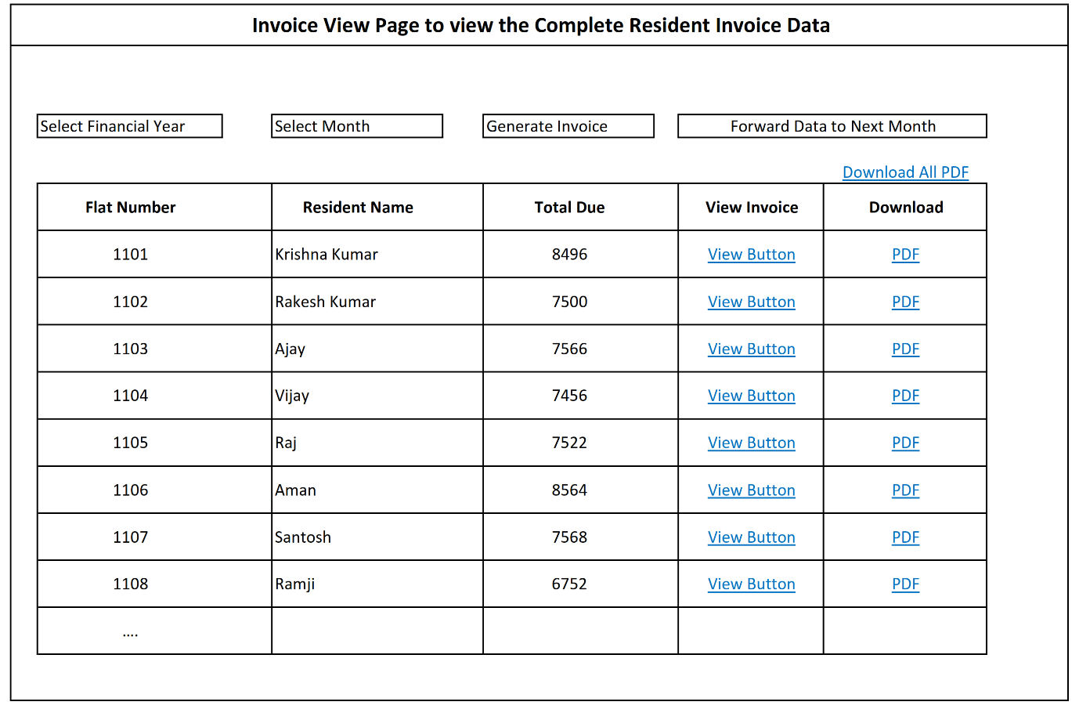

**Page: 3** This Page will contain the details of the invoice items. By using this page Admin accounts will perform following operations:

1. Invoice can be editable. Admin accounts can add items, remove items by using Edit button.
2. Invoice can be cancelled and new invoice with new number can be generated. In case of Delete / Edit of invoice fresh invoice number will be generated.

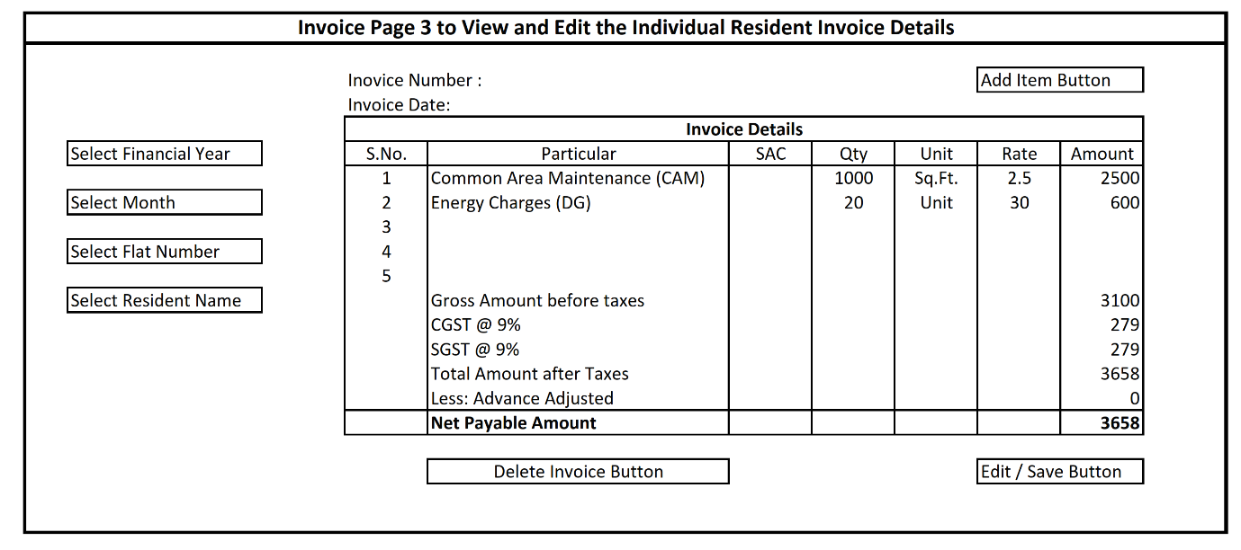

**Page 4: (Ledger)** All the data of Page 3 screen of each resident will be maintained inside a ledger. All the payment that will have to be paid by resident will be mentioned in credit section. After resident will paid the amount, it will have mentioned in debit column. Admin accounts will select a flat ledger and will find the details of individual resident. Amount that will be due in a particular previous period will be shown in opening balance. Amount that will be due in a particular current period will be shown in closing balance and mentioned in to the next month as opening balance. Admin account could see the ledger by selecting ledger name and period.

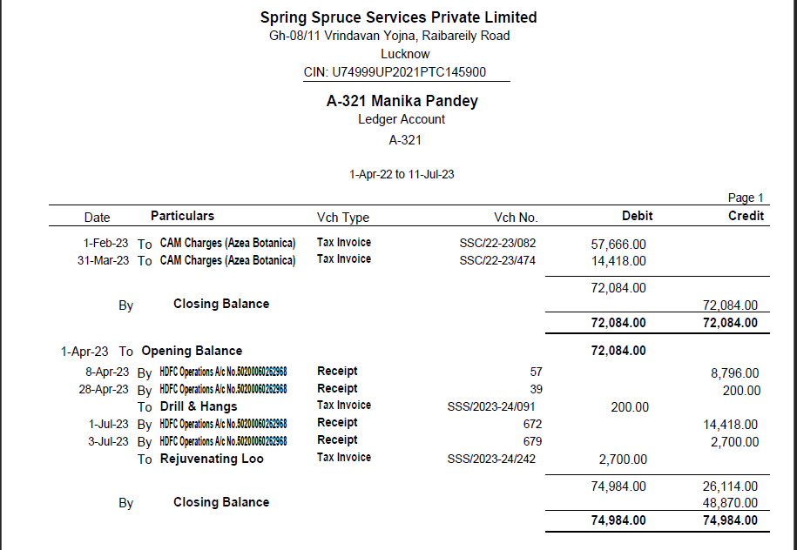

**Mobile Version:**

Mobile version of module will be used by the resident to get the dues and make payment against those dues. Resident will get invoice of each month on scheduled date in pdf format in the App. Resident will have the option to pay the due or make advance payment.

|  |  |  |
| --- | --- | --- |
|  | Resident can get the **Payments** option by clicking the button **Society dues** placed on the dashboard. Here resident will view the following:   1. Financial year wise all the invoice, **New** and **Paid** both with download option. 2. Resident can also view the total dues, total deposit and total advance. | |
| C:\Users\Shikhar\Downloads\WhatsApp Image 2022-10-27 at 13.50.18.jpeg | | By choosing the MAKE PAYMENT option resident can Pay Dues or Pay Advance. After selecting dues resident will select the payment gateway and pay the selected amount. Same process will be followed in the Pay advance option. |